**Different Resources/Services Attached to EC2**

* AWS EC2 instance should be created in some AZ.
* By default in every AWS region, AWS pre-creates a default vpc with subnet for each AZ.
* While creating the ec2 instance, we can select AZ by selecting subnet
* When we select a subnet an Elastic Network Interface (ENI) will be getting a private ip and will be attached to ec2 instacnce.
* Public ip is enabled by default.
* Public ip is not charged by default, when we create an ec2 instance AWS has a large pool of available public ips and one public ip will be used for mapping public ip to private ip.
* When we shutdown the ec2 instance, the public ip is released & will go back to aws public ip pool.
* So thats the reason the public ip changes after stopping and starting the ec2 instance.
* If we need same ip even after restart, then we need go pay for static ip address which is referred as elastic ip.
* AWS also gives a dns name for public ip and private ip (in default vpc’s).
* To filter out which traffic that is allowed to your ec2 instance, we use security group  
  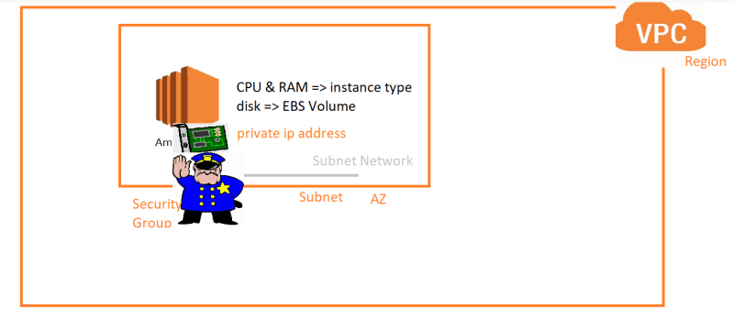
* To login into ec2 instance we need credentials i.e. key pairs
* For now i will be using existing key pair created in previous session  
  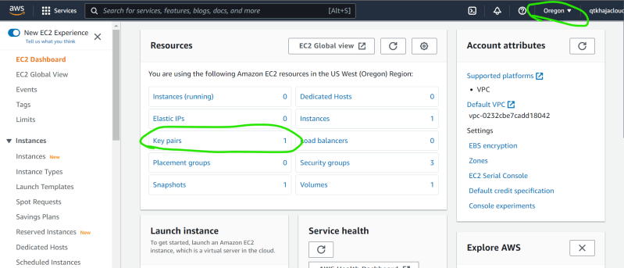
* Lets create a security group which allows ssh connection from any where (SSH => 22 port)  
  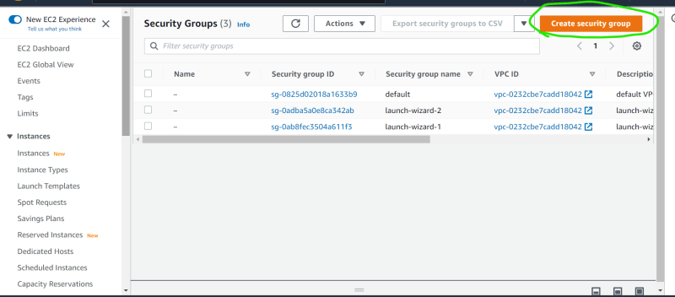  
  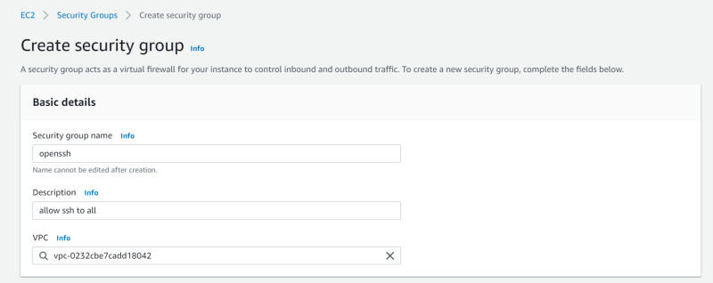  
  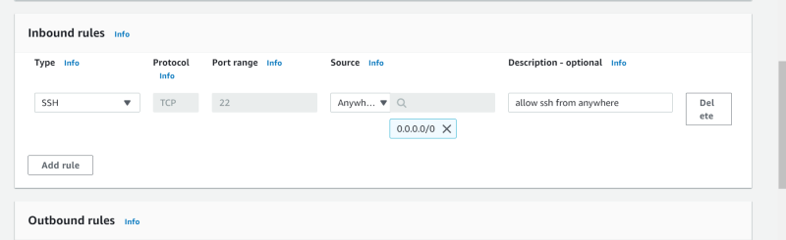  
  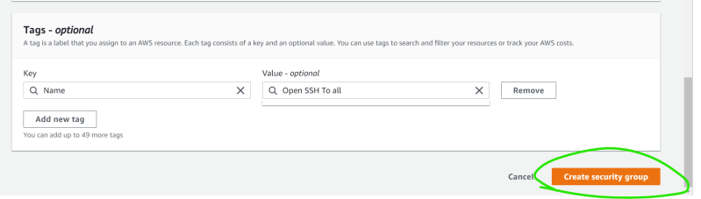  
  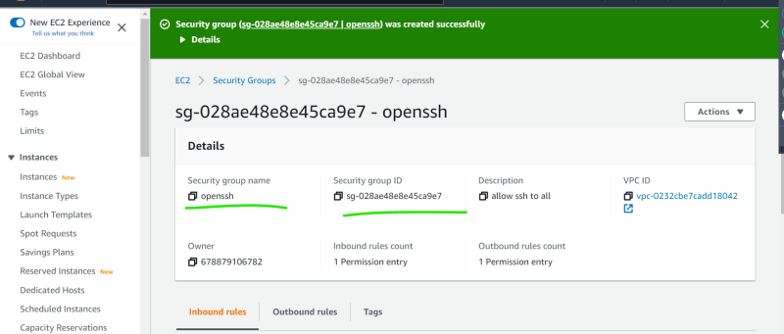  
  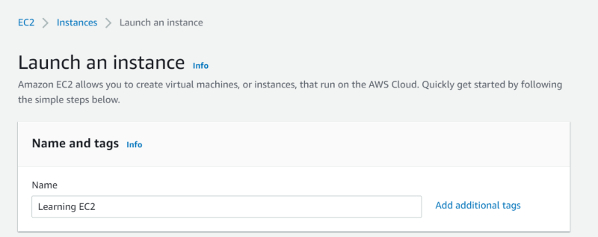
* Lets select an AMI (Amazon Machine Image). See below for basic AMI intro  
  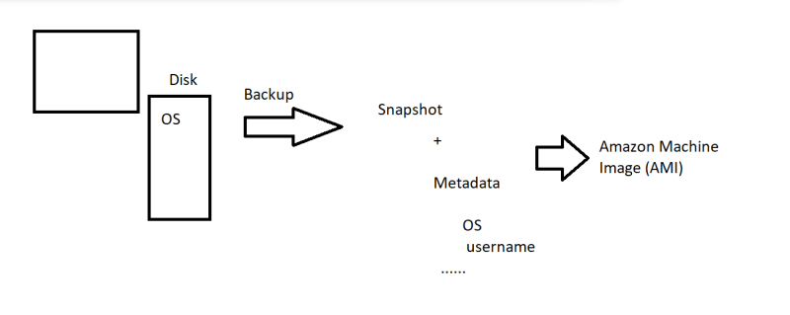  
  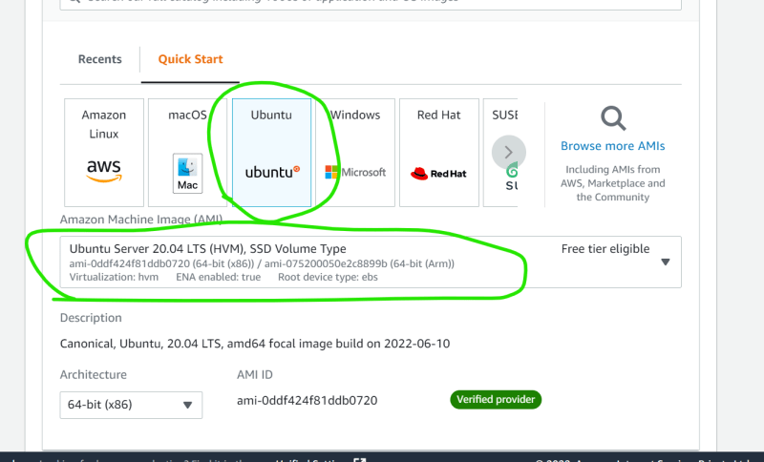  
  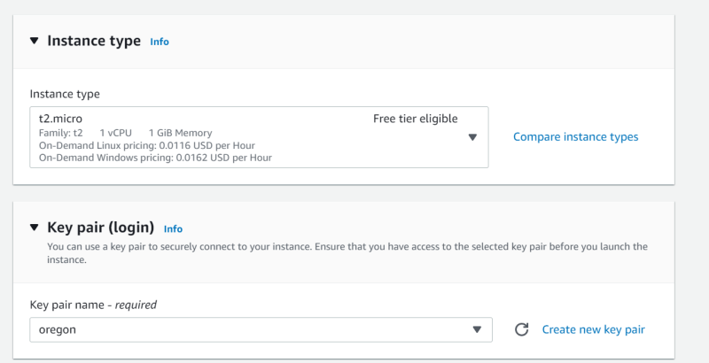
* Now lets select Network Settings
  + Public ip or not
  + Which AZ
  + Which Security Group  
    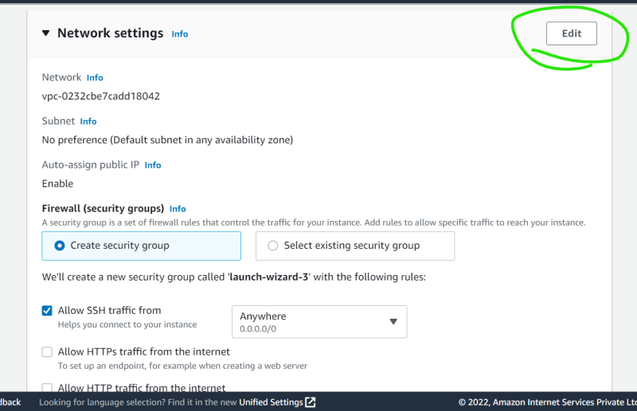  
    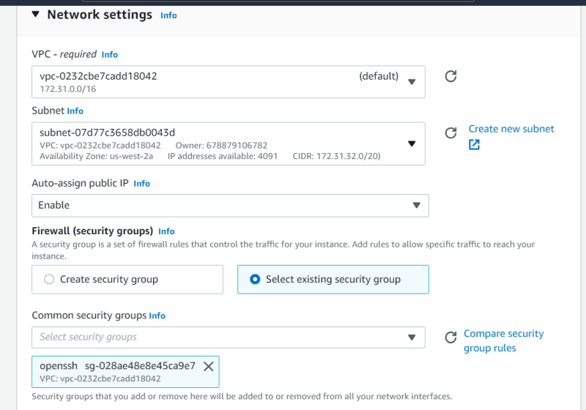  
    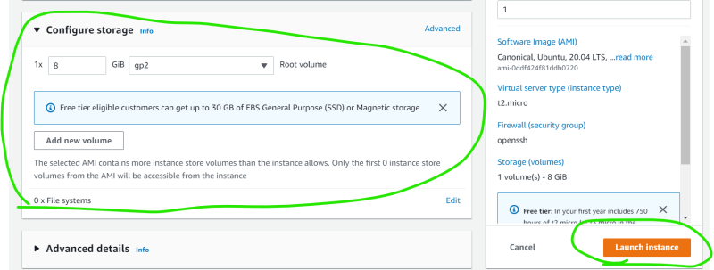  
    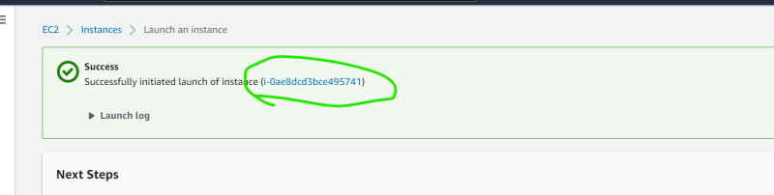  
    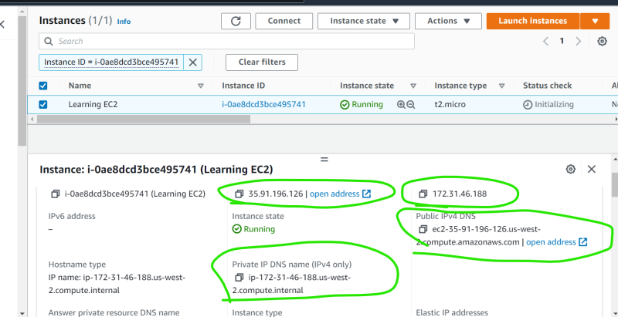
* Lets connect to this ec2 instance
  + Command ssh -i <path to pem> username@<ip address>  
    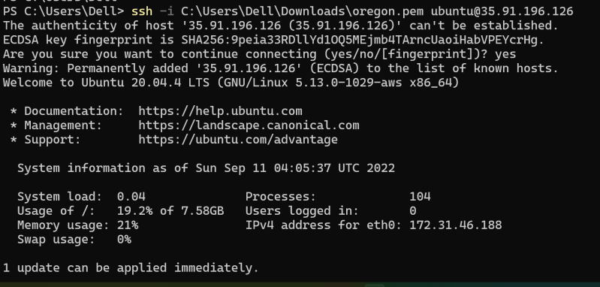  
    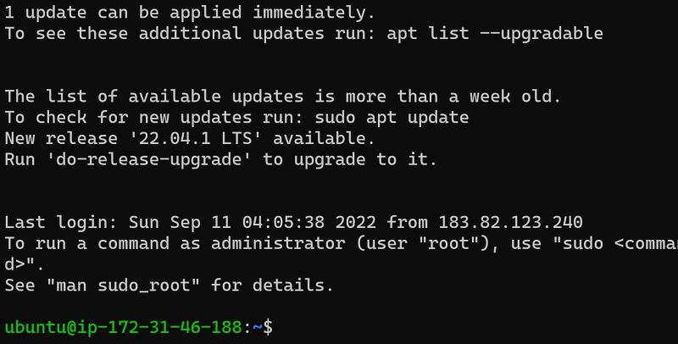
* Lets look at
  + ENI  
    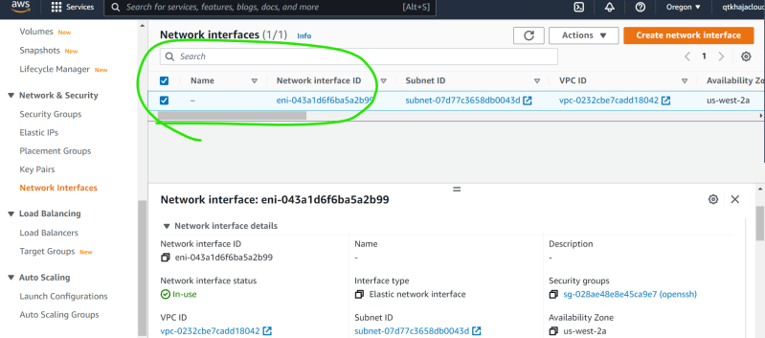
  + EBS Volume  
    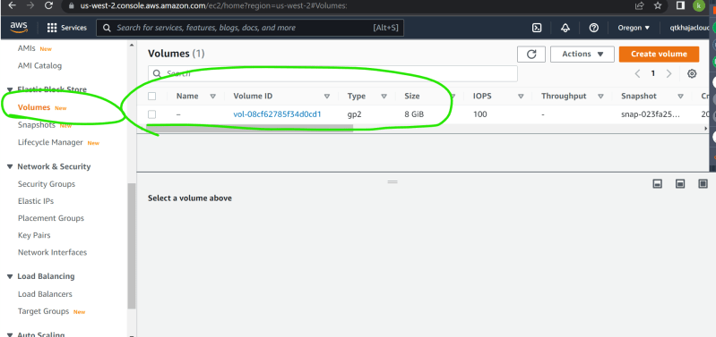

**Activity 1:**

* Create a new key pair called as ec2learning.pem in the region of your choice
* Create a new security group which open
  + tcp 22 port for every one
  + tcp 80 port for every one
* Create an ec2 instance in the AZ-B
* Ensure the machine has public ip
* Create the instance with ubuntu 18.04
* Login into the ec2 instance and execute the following commands

sudo apt update

sudo apt install apache2 -y

sudo apt install stress -y

* browse http://<publicip&gt;

**Activity 2**

* We are generating a key pair by using AWS
* Now lets create a Key pair on your laptop and upload the public key to AWS
* Launch Powershell and execute ssh-keygen  
  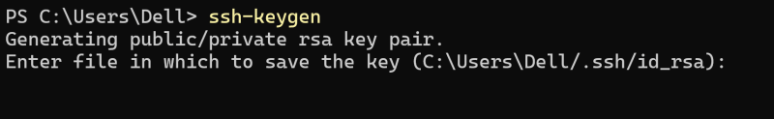
* Now navigate to ~\.ssh  
  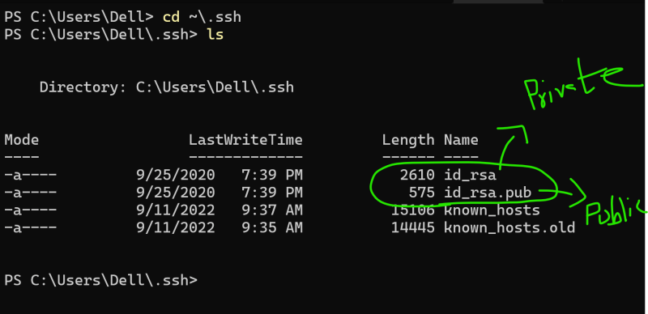
* id_rsa => private key
* id_rsa.pub => public key
* Now open key pairs section from ec2 console  
  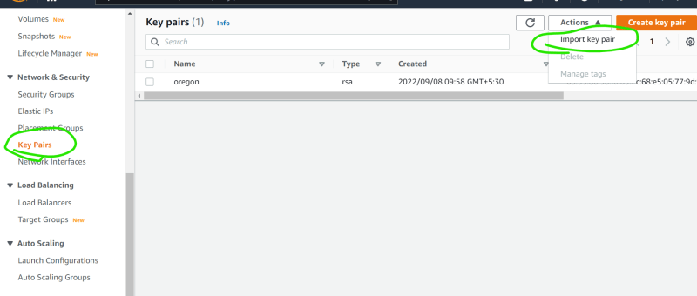  
  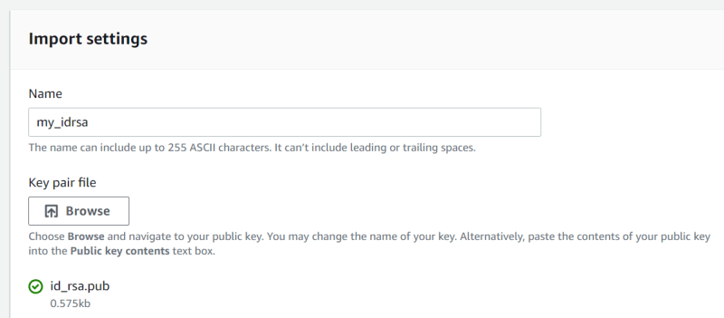  
  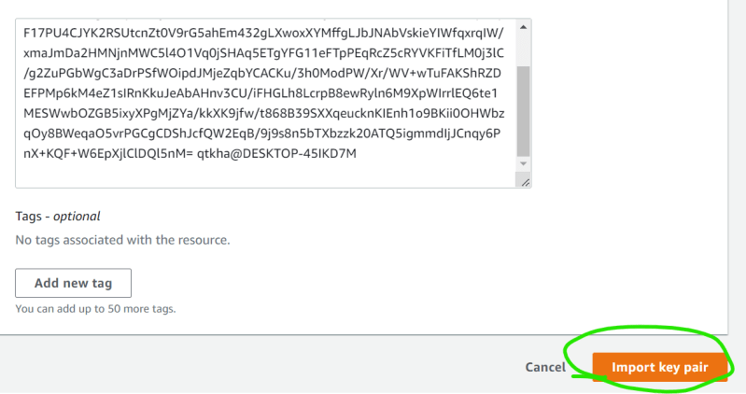
* Now repeat Activity 1 with imported key pair  
  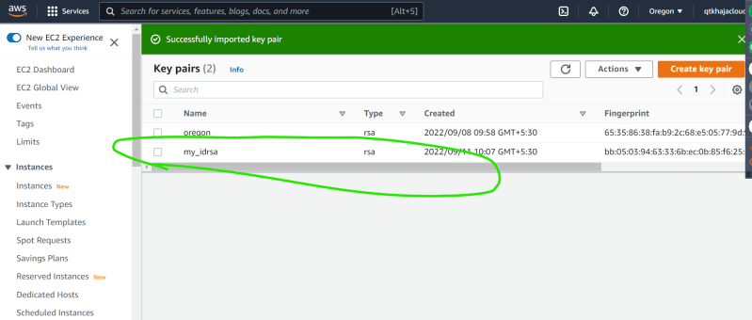
* Login into ec2 instance (ubuntu 18) ssh -i ~/.ssh/id_rsa ubuntu@<publicip>  
  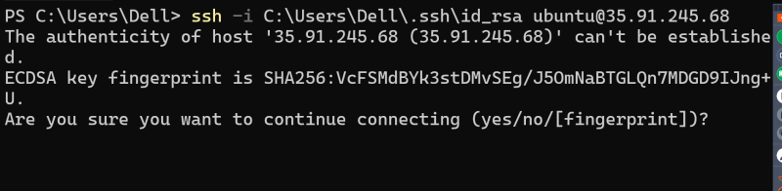  
  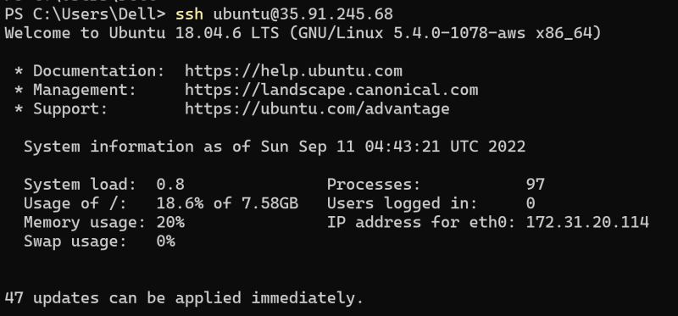  
  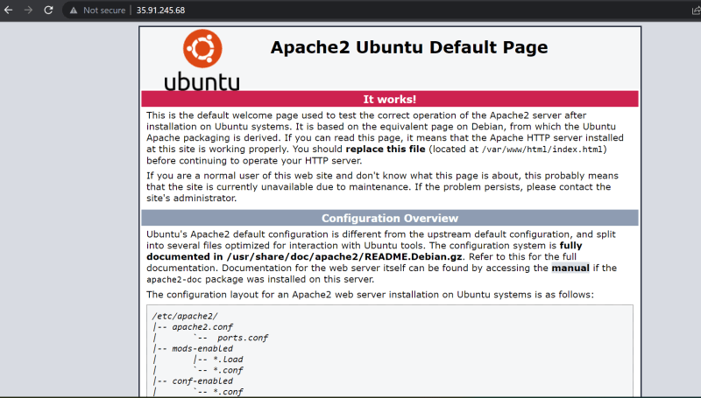
* Note: Delete all the instances after usage.